################### How to Change Proxy Port #############

1. Type Internet Options in “Type here to Search Field”

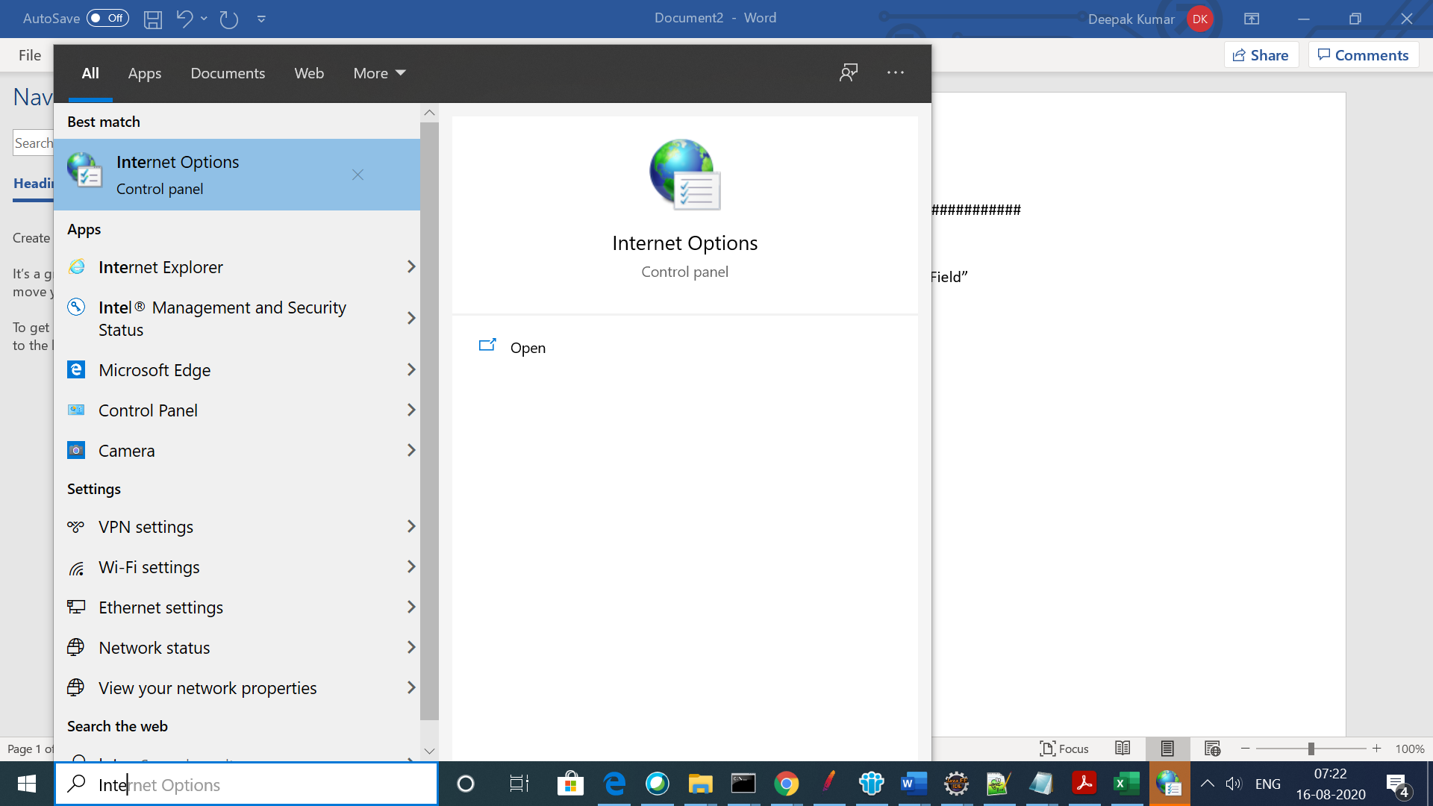

1. Click on Internet Options and then click on Connection and then LAN Settings

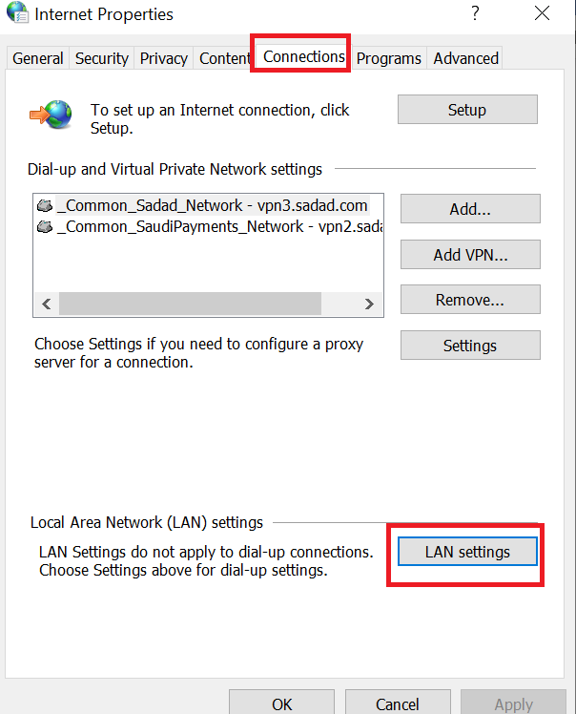

1. Select Proxy Server check Box and then change the port number from 80 to 8888( JMeter default Port)

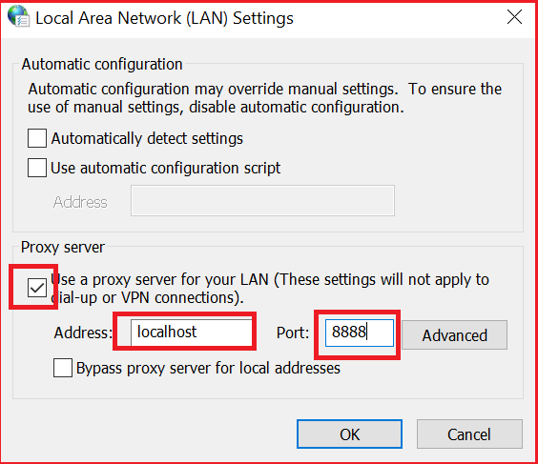

1. Click on ok button.